Kingsmark Properties
www.kingsmarkproperties.co.uk
To Let

22 WESTERN AVENUE, BULWARK, NP16 5NW
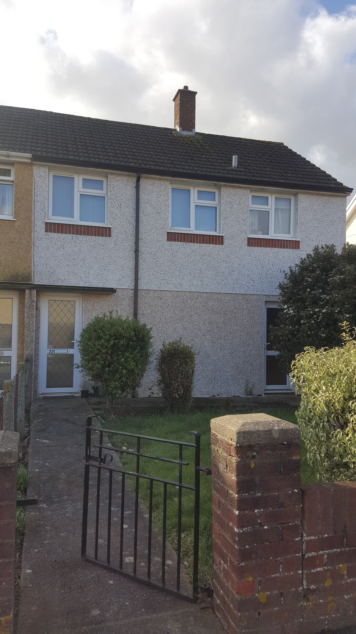

£575 PCM
UNFURNISHED 2 BEDROOM HOUSE
FITTED KITCHEN, BATHROOM. SPACIOUS LOUNGE, GARDENS,
PARKING
Tel: 07795103686

